Planning for the displaying of data in a way that is easy to access and intuitive

By:

Michael Katsoulis

Amaan Vally

Macmoses Wana

**System Overview** **3**

**Reading in Data** **3**

Process: 3

# System Overview

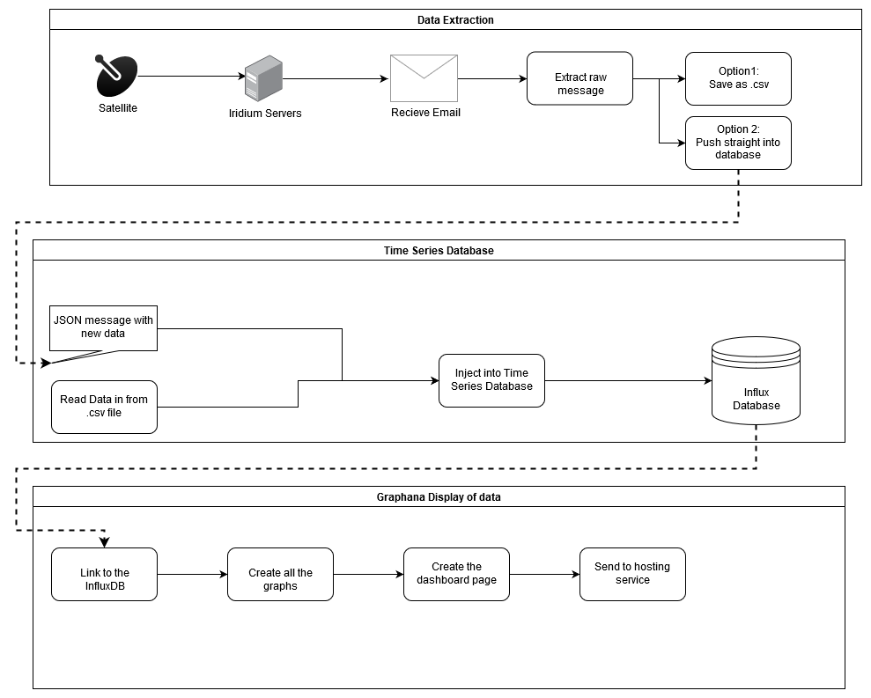

# Reading in Data

## Process:

Get email → Read Email → extract message data → Process message and break down into values → Export in a useful format

# Using the Time Series Database

InfluxDB was found to be the best database for this application.

It allows for rapid scaling. Each data entry uses the time value as it’s defining characteristic. This lets us decide how data will be compressed over a week, month or year.

This means more efficient databases, faster querying and better data management.

As a bonus, Grafana - the open source graphing software that we will use to make the dashboard - integrates directly with Influx. This will make the displaying of data much easier.

This database will be a standalone file.

It is where information will be accessed and injected.

There may be a need to write a program using something line NodeRed to insert information into this database from a .csv file.

# Dashboard and output of data

Visualisation:

Grafana is an open source graphing system. It will allow us to make it easy to visualise data.

An example of what a dashboard built with Grafana looks like:

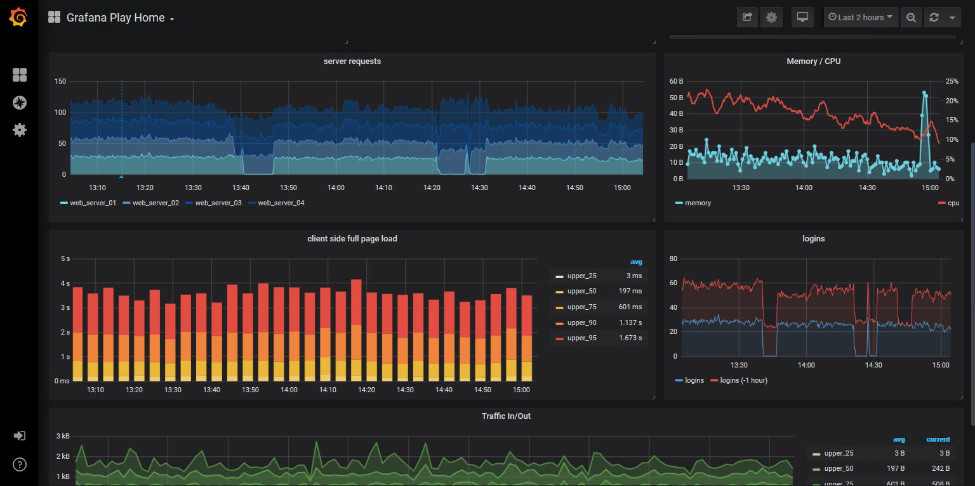

There are several packages which will allow us to output the data on a map. This map can be made to change with time to give a visualisation of the changing environmental factors.